**COMP2451 Game Design & Engineering**

**Game Design & Development Project**

**Development Document**

**Project/Game Title:**

**Panacea**

**Student Name:**

**Kristopher Randle**

**Student Number:**

**18008890**

Contents

1 Amendments to game design 2

2 Amendments to the game engine 3

Changes & Additions to the Engine code 3

3 Prototyped gameplay mechanics/features 6

Development Schedule 6

Mechanic / Feature 1: 7

Mechanic / Feature 2: 7

Mechanic / Feature 3: 7

Mechanic / Feature 4: 9

Mechanic / Feature 5: 10

Mechanic / Feature 6: 12

Mechanic / Feature 7: 13

4 Reflection on the game development project 16

4.1 What went well 16

4.2 What could have gone better 17

4.3 Project management 17

4.4 Milestones 17

5 References 19

# Amendments to game design

In the initial game design document, a name for the game was not specified. To coincide with the concept of the game, it was named “Panacea”, which links into the medical aspects of the project. The main reason a name needed was for organisation in the project when naming files, rather than simply calling everything “COMP2451GameProject”.

The initial game design document also failed to focus on more simplistic mechanics that would need to be implemented to make a functioning game. It only looked at more advanced mechanics, such as time trials and power-ups without addressing basic mechanics such as movement, interacting with doors, and wall collision. As such, some further mechanics will need to be added and implemented first before the more advanced ones. The new mechanics that will be implemented are:

1. Basic player movement. Walking with the W, A, S, D keys.
2. Animated Sprites.
3. Spawning a world with a TileMap, with separate collidable and non-collidable layers.
4. Entities colliding with walls and other entities/objects.
5. A camera that can track the player,with zoom functionality. (Mouse input)
6. A Sprint Mechanic (With a changing animation).
7. Roaming NPCs (Mary Herbert, Barry B, etc)
8. Player-Object interactions, such as picking up an item or interacting with a door.
9. Dialog boxes when talking to the NPCs.
10. Treating Patients by interacting.

No other amendments were made to the game design; however, the entire scope of the game project could not be created in the allotted time scale. As such, the game project features a working prototype model rather than a final polished game.

The art assets used in the game were acquired from:

*https://opengameart.org/content/zelda-like-tilesets-and-sprites* *https://opengameart.org/content/tiny-characters-set.*

These assets are royalty-free. These Art assets were chosen as they match the initial design document in terms of game context, which describes a 2D game set in a hospital.

# Amendments to the game engine

No major changes were made to the actual game engine architecture. Additions were made to extend the functionality, but previous functionality was not altered to incorporate new mechanics since the engine was made properly generic. A minor rework in the way collisions was handled massively improved the efficiency of the collision manager.

## Changes & Additions to the Engine code

1. Added an IUpdatable(GameTime gameTime) interface, which all classes that have an update loop inherit. This allows all update loops to be called in one place, improving program efficiency and overall code structure.
2. Added an AnimatedEntity Class which was designed to be generic, meaning it can be used for any game - not just Panacea. This was needed to implement the animated sprite mechanic/feature.
3. Added an Animation Class to the engine. This can store a series of animation frames which can be cycled through at a given FPS. This was also made to be generic and versatile. As such, you can use this class with any sprite sheet (Image file)and crop out any specific part you wish in the software to create your animations.
4. Added a Sprite Class to the engine. Again, this was made to be generic so it could be used for any game project. This was needed to implement mechanic 2.
5. Added a GameEntity class to the engine. This was also made to be generic so that it could be used in any project, this was needed to implement any spawnable entities such as the Player, NPCs, Tiles, and Objects.
6. Created a Camera class for the game engine which can track the player’s position. The user can also zoom in and out using the mouse scroll wheel. This mechanic was added to match the nature of the game concept presented in the pitch milestone, which detailed a chaotic hospital ward with patients that the player would need to strategically manage. The zoomed-out camera allows the player to gain an oversight of the whole level and plan where they need to head next.
7. Mouse input functionality was added to the InputManager. This was needed in the game to handle zooming in and out with the new Camera.
8. Added UserEventArgs “OnMouseInputEventArgs”
9. Reworked Interface ISceneManager to have a property to retrieve the SceneGraph. This limited the amount of typecasting required in the Kernel to access the SceneGraph, massively improving code readability. Not having this in place prior also made the interface pointless, since you had to keep casting to the parent type from the interface which defeated the point.

Made IInputManager inherit IInputPublisher, this allowed the removal of typecasting from IInputManager -> InputManager.

The CollisionManager caused major optimization and performance issues due to checking hundreds of ICollidables for collisions on each update. It had to be reworked to do fewer checks and only ones that were needed. To accomplish the optimisation a collision graph was added to the CollisionManager. This will store ICollisionResponders in a collision graph, and ICollidables in their own ICollidables list. This eliminated an extra check on each update loop, optimizing the collision checks slightly. The Count() method was also changed to the Count property, which added a very minor optimisation as it prevents extra external checks via method calling. The old Collision Manager was checking if everything collided with everything, this meant walls would always be checking if they hit other walls, etc. Splitting into 2 groups meant only the ICollisionResponders were checking if they hit things. After running visual studio's built-in profiler, it was found that over 90,000 checks (300 squared) were being performed every update loop, causing the PC to freeze and crash.

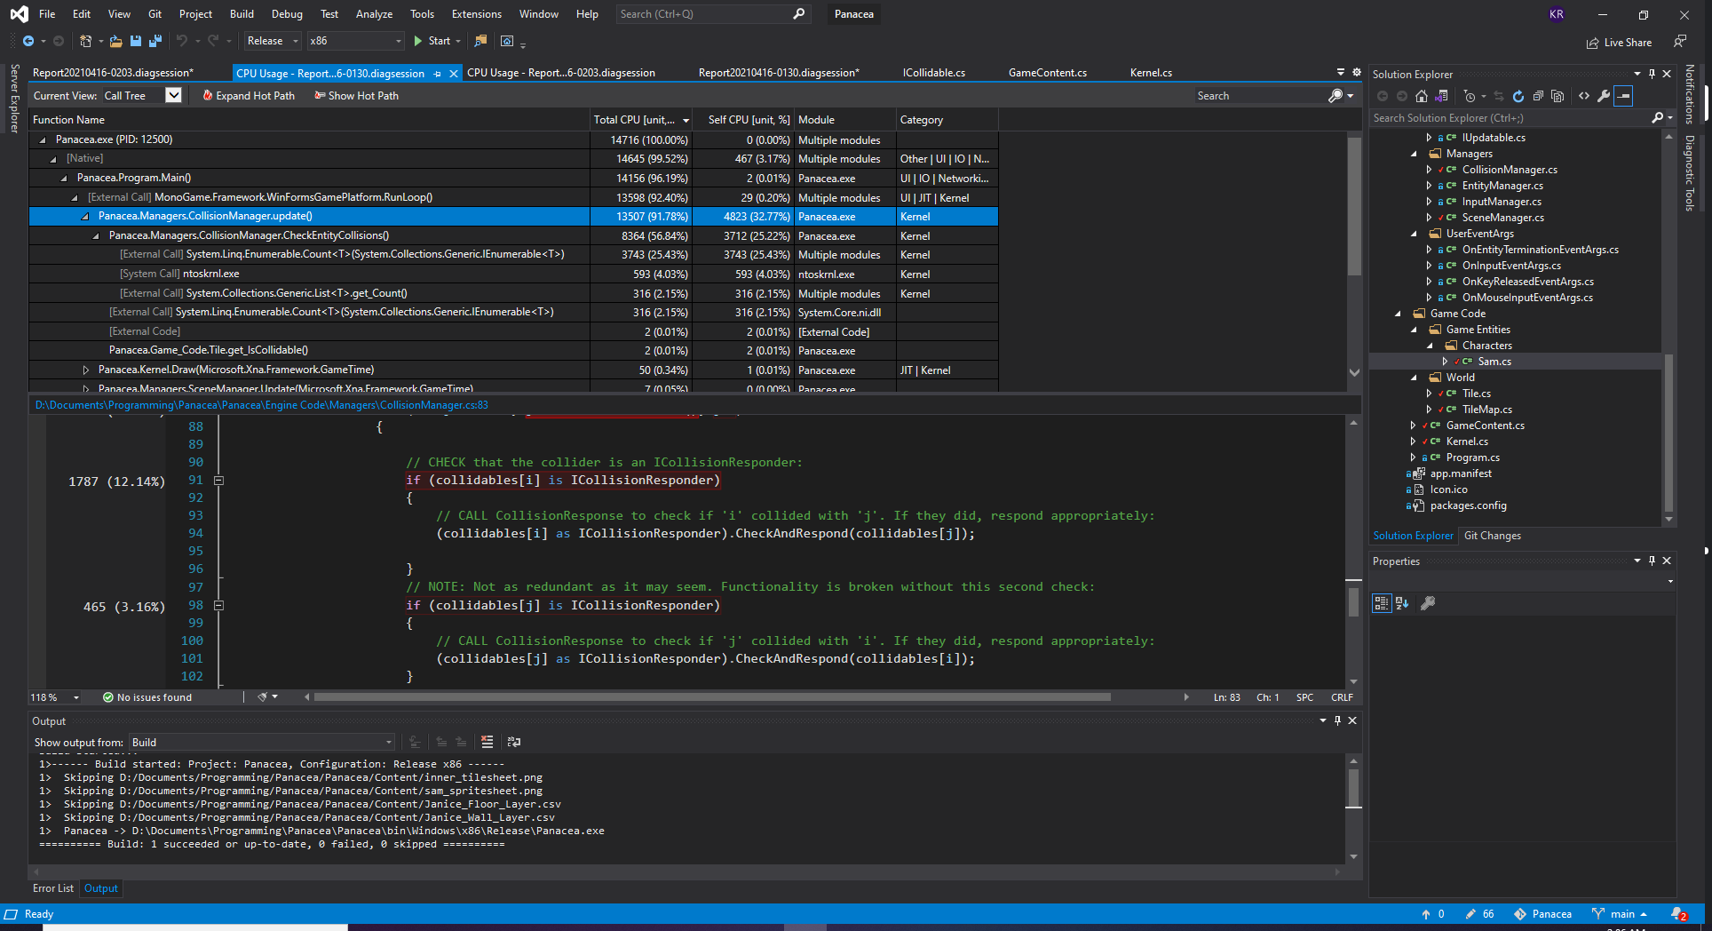

Figure 1: A screenshot showing the summary of the profiler report, showing that the CollisionManager was responsible for the performance issues. (91.78% CPU Usage!!)

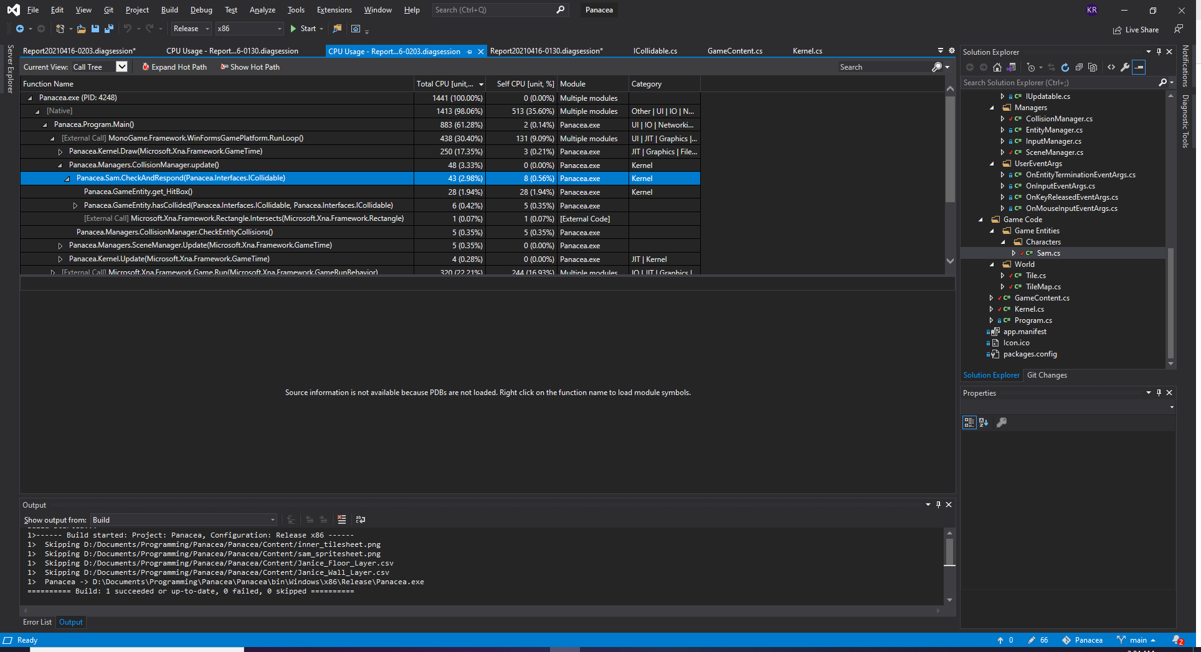

Figure 2: The Profiler report after making optimisation changes to the CollisionManager. The Manager was now only using 3.33% CPU Usage and still performed all Collision Calculations.

As is evident in the above profiler screenshots from Visual Studio, the change made to the Collision Manager CPU usage from 91.78% on the Hot Path to 3.33%. This was a huge fix which meant that the program could actually run normally and was playable again and shows that an issue like this can be hard to detect in previous versions where Pong only had 3 entities in the game. It highlighted how unscalable the previous iteration of the Collision Manager was, and also how game development is an iterative process with adapting needs over time.

1. The final addition to the Engine side of the code was the NavigationManager. The NavigationManager makes use of the A-Star (A*) algorithm, an adaptation of Dijkstra’s algorithm. The algorithm is detailed by Hart, Nilsson, and Raphael (1968) in their original paper. The implementation of the algorithm was derived from the pseudocode provided on Wikipedia (n.d.). The NavigationManager starts by holding a List of IPathFinders, which will contain all Roaming NPCs and a Navigation Grid. The Navigation Grid is a TileMap that the IPathFinders should traverse around. The NavigationManager then gives all of the IPathFinders a suitable path if they do not already have one by:

Selecting a random Tile from the TileMap that is “walkable”. This works by using the Collision Layer TileMap and selecting all Tiles that are not walls using a random value.

Calculates the shortest path to the newly selected destination from the entity's current location using the A-Star algorithm. This makes use of Euclidean distance and a CalculateAdjacentTiles() method to find the optimal path.

Returns the new calculated path as a List<Vector2>, containing the coordinates that the NPC needs to walk to at each step in the path.

The NPC then ‘follows’ this generated path to the randomly selected destination tile, taking the shortest route. Once the NPC finishes their course, they will wait for 5 seconds. After 5 seconds, the NavigationManager performs a check to see if they have finished their previous path before assigning them a new random path following the same procedure.

The result is an NPC that randomly roams around the levels without colliding into walls, taking the shortest path to a given area before waiting and repeating.

# Prototyped gameplay mechanics/features

## Development Schedule

This schedule presents the mechanics that will be incorporated in each version of Panacea. A Schedule was deemed appropriate given the iterative nature of the project which spans 4 milestones. The prototype will aim to have Versions 0.1 – 0.9. If all are completed in the prototype, some Mechanics listed in versions 1.X will be completed if time permits. It is unlikely that any mechanics in Version 2.X will be completed in the scope of this prototype, but these are what could be incorporated in the future.

|  |  |  |
| --- | --- | --- |
| **Implemented** | **Version** | **Mechanics/Features** |
| ***Badge Tick with solid fill*** | ***0.1*** | *Walking with W, A, S, D* |
| ***Badge Tick with solid fill*** | ***0.2*** | *Animated Sprites* |
| ***Badge Tick with solid fill*** | ***0.3*** | *Spawning a world with a TileMap, with separate collidable and non-collidable layers* |
| ***Badge Tick with solid fill*** | ***0.4*** | *Player Token colliding with Walls and other Entities* |
| ***Badge Tick with solid fill*** | ***0.5*** | *A Camera that can track the player, with zoom functionality. (Mouse input)* |
| ***Badge Tick with solid fill*** | ***0.6*** | *Sprint Mechanic (With a changing animation)* |
| ***Badge Tick with solid fill*** | ***0.7*** | *Roaming NPCs using a Pathfinding algorithm* |
| ***Badge Cross with solid fill*** | ***0.8*** | *Dialog Boxes when ‘talking’ to the Roaming NPCs* |
| ***Badge Cross with solid fill*** | ***0.9*** | *Player-Object interactions (Picking up items, opening doors)* |
| ***Badge Cross with solid fill*** | ***1.N*** | *‘Treating’ Patients through interacting* |
| ***Badge Cross with solid fill*** | *Timed Tasks* |
| ***Badge Cross with solid fill*** | *Dynamic Music* |
| ***Badge Cross with solid fill*** | *Activatable Abilities* |
| ***Badge Cross with solid fill*** | *A Box/Device that the player can review the game lore with* |
| ***Badge Cross with solid fill*** | ***2.N*** | *Class System* |
| ***Badge Cross with solid fill*** | *Power-Ups* |
| ***Badge Cross with solid fill*** | *Stealth* |

Mechanic / Feature 1:*Walking with W, A, S, D*

This mechanic was relatively easy to implement because the previous version of the Pong Engine was well developed with generic Input Management. The “Keys of Interest” system was still employed from the previous version which can be specified in each IInputListener. An IInputListener stores the keys that can be used to control it, and the InputManager holds a List of IInputListeners. The InputManager performs a sum calculation to check which keys all listeners want to know about before determining which keypresses to fire events about. For instance, if one IInputListener uses W,A,S,D and another uses Up,Down,Left,Right, the InputManager will only fire key events relating to: (W,A,S,D,Up,Down,Left,Right). This prevents the InputManager from firing off events for key presses that none of the listeners/subscribers care about (wasting resources). From here, it was easy to register W, A, S, D to the player and then react accordingly to make the player move around the screen. This mechanic is an integral part of the gameplay posited in the original design document.

Mechanic / Feature 2:*Animated Sprite*

Animation required the creation of a few classes in the engine code. Animation.cs, AnimatedEntity.cs, and Sprite.cs were all created to tackle to task of making the player animated. The Animation class holds a List<Sprite> animationFrames which holds each individual image used on each frame of the animation sequence. A ‘Sprite’ is just a graphical representation of an object, which can be created from any sprite texture sheet you want. The implementation of this system meant that individual frames didn’t have to be cropped out for each frame of the animation from a sprite sheet. They could instead just incorporate the whole sprite sheet with all frames on to be extracted in the software. This method is also preferable since it saves on system resources since only 1 image needs to be loaded per animation sequence rather than potentially dozens.

AnimatedEntity is a child class of GameEntity, holding only one extra field – Animation entityAnimation. This is just an instance of Animation which has been preloaded for each specific entity and can be cycled through/changed.

To make the referencing of each animation easier, all animations were stored in a new class called GameContent.cs in a Dictionary containing Animation objects. These Dictionary elements were indexed using an Enum called ‘AnimationGroup’ so that when the time came to change an entities animation, it could be done easily, for instance:

***if(KeyInput == Keys.W)***

***{***

***this.entityAnimation = GameContent.GetAnimation(AnimationGroup.SamWalkUp);***

***}***

Mechanic / Feature 3:*Spawning a world with a TileMap, with separate collidable and non-collidable layers*

To ensure continuity with the original pitch design document, the game world was designed to represent the hospital ward set out prior. As such, the TileMaps use game assets that match the stylistic nature of an RPG hospital.

To implement the TileMap feature, a Tile and TileMap class had to be created in the game code to generate the world. A Tile is a child of the GameEntity class and implements the ICollidable interface so the CollisionManager can keep track of its collisions (and allows other objects to collide with certain tiles.) Each tile can also be independently set to ‘isCollidable’, so some tiles (such as floor tiles) can be walked over by the player, whereas wall tiles cannot be walked over. Each Tile makes use of the new Sprite.cs class to give it a graphical representation.

The TileMap class contains a 2-dimensional array of Tile objects, called ‘tileMap’. The implementation of the actual mapping was a tricky task and a 3rd party program called “Tiled” created by Lindeijer, T (2021) was used to help. Tiled can be found here: https://www.mapeditor.org/.

Essentially, Tiled allows you to ‘draw’ your Tile Map using your in-game asset images. It can be used to create multiple ‘Layers’, which is used to separate layers that were collidable and to help stack images on top of others such as objects on tables. Once the TileMap was drawn, the software allows you to export it as a .csv file for each layer. This .csv file contains a series of integers separated by commas, with each integer representing a tile with a specific texture. The Tiled editor can be seen below:

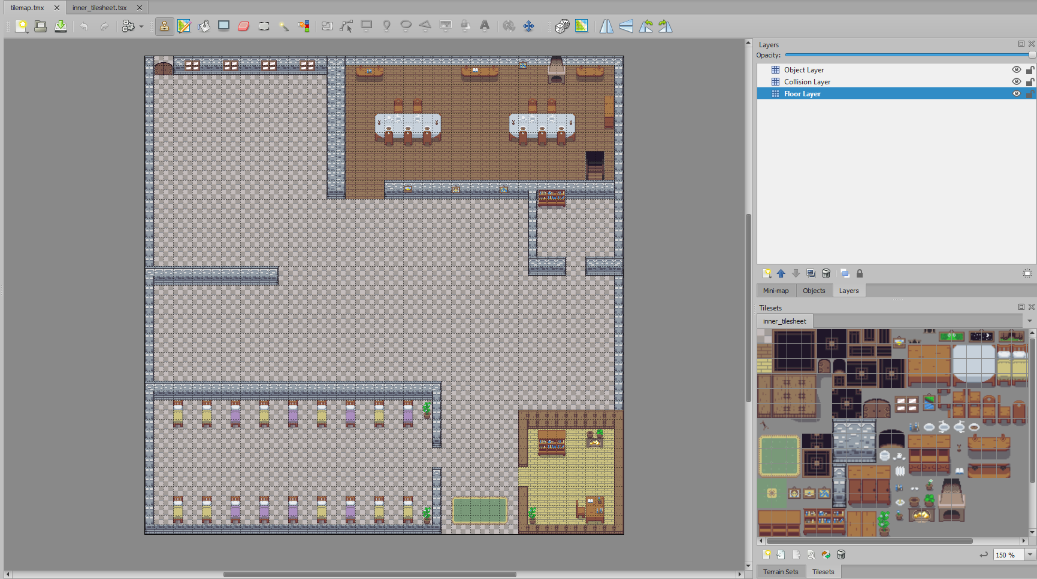

Figure 3: Tiled TileMap editor, used for creating the levels TileMap.

The output of the “Floor Layer” Tile Map looks like this in the .csv file once Tiled has exported it:

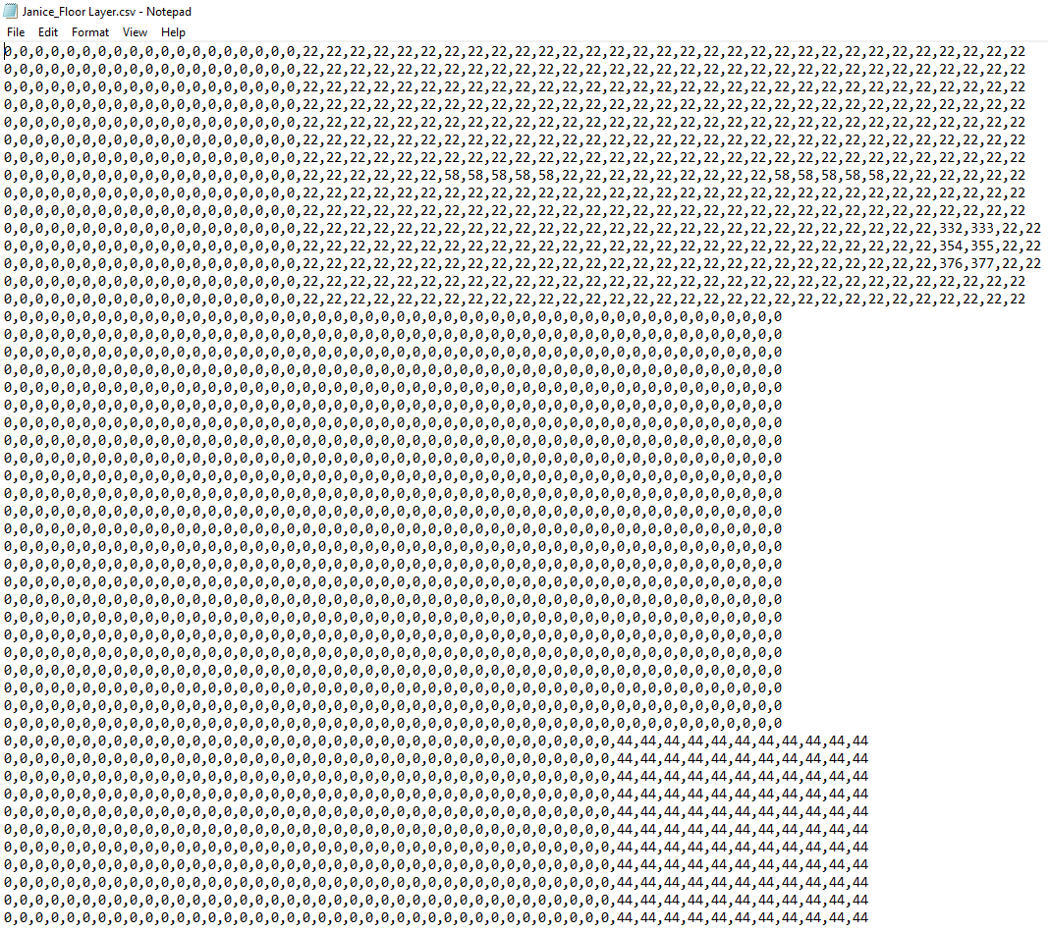

Figure 4: The .csv output file from Tiled, representing the Floor Layer TileMap.

From here, all 3 .csv files were imported into the MonoGame framework and were read by a ParseFile() method in the TileMap class. This method reads in the .csv file where it is separated by commas to extract each integer. Each number is then mapped to each tile as its unique ID number, which can be later used to set its texture. The LoadTileMap() method also checks if the tile contains an image, if the number in the .csv file is -1, the tile does not have a texture and therefore will not be drawn. This prevents the SpriteBatch from rendering redundant, invisible tiles and wasting system resources. Before storing the new Tile in the TileMap, the program checks if the tile is sitting on a collidable layer and sets each tile to “IsCollidable” if it is a collidable layer. Each tile has its location set in the map based on the default tile width and height of 16x16 pixels.

Finally, to draw each TileMap layer, the DrawTileMap() method can be called which takes the SpriteBatch as a parameter to draw the maps onto.

Mechanic / Feature 4:*Player Token colliding with Walls and other Entities*

The player collision was also relatively easy to implement given that Collision Management was made properly generic in the previous milestone. To adapt it for this program, the Player Token inherits ICollidable and ICollisionResponder, and the CollisionManager checks if the Player has crashed into any other ICollidable objects. Setting up the TileMap properly in the previous mechanic feature was essential in making this step easy. Since each Tile has a Boolean stating whether it is collidable or not, it is easy to implement the checks and to make sure the player only collides with wall tiles. To visualize, the only collidable layer looks like this:

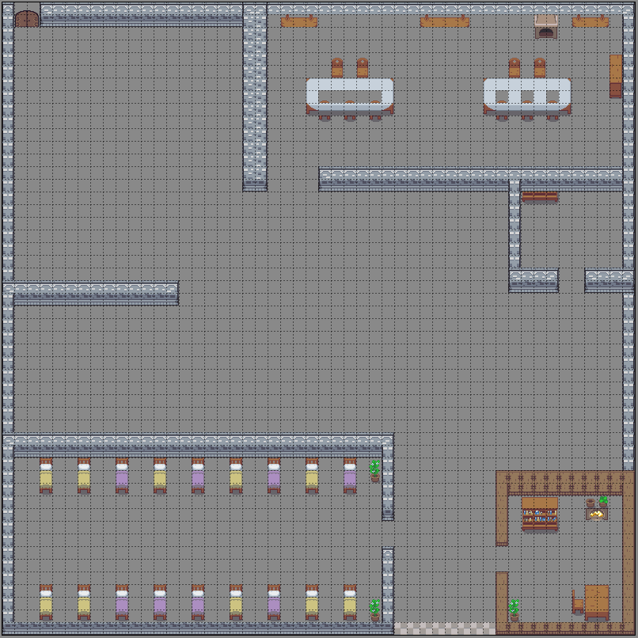

Figure 5: A screenshot of the Collidable TileMap layer.

The blank, grey tiles represent tiles that the player can freely walk over. Texture tiles cannot be walked on by the player or any other Game Entity and will invoke a collision response from the Collision Manager.

Mechanic / Feature 5:*A Camera that can track the player, with zoom functionality. (Mouse input)*

A camera was implemented since the images in the game are small pixel art images, which would ordinarily be too small to see properly on the game screen. It was also added to allow the player to gain an overview of the Hospital Ward and strategically manage patients that needed treating in all sections of the wards, since the original game design suggested intensive patient management.

The camera tracks the player's movement, and the zoom aspect can be controlled using the mouse scroll wheel. To allow for this, the Input Manager functionality had to be extended to support mouse input. The camera was also made generic and can ‘SetFocus()’ onto **any** GameEntity by calling the appropriate method. This means the user can easily change the camera's focus onto anything else in the game, such as NPCs.

The camera uses a transform Matrix and the zoom aspect (set by the scroll wheel value) to calculate the scale for the viewport. In its current state, the Camera implements IInputListener for the mouse scroll input and has the functionality to be extended in the future to be moved using arrow keys. Again, the Input Management is handled using events/delegates rather than polling which means the scrollValue can be accessed from OnMouseInputEventArgs and added to the Zoom Aspect.

From the screenshot below, you can see how this camera can be useful for the overall gameplay. It allows the user to see exactly what is going on in all parts of the level when they need to.

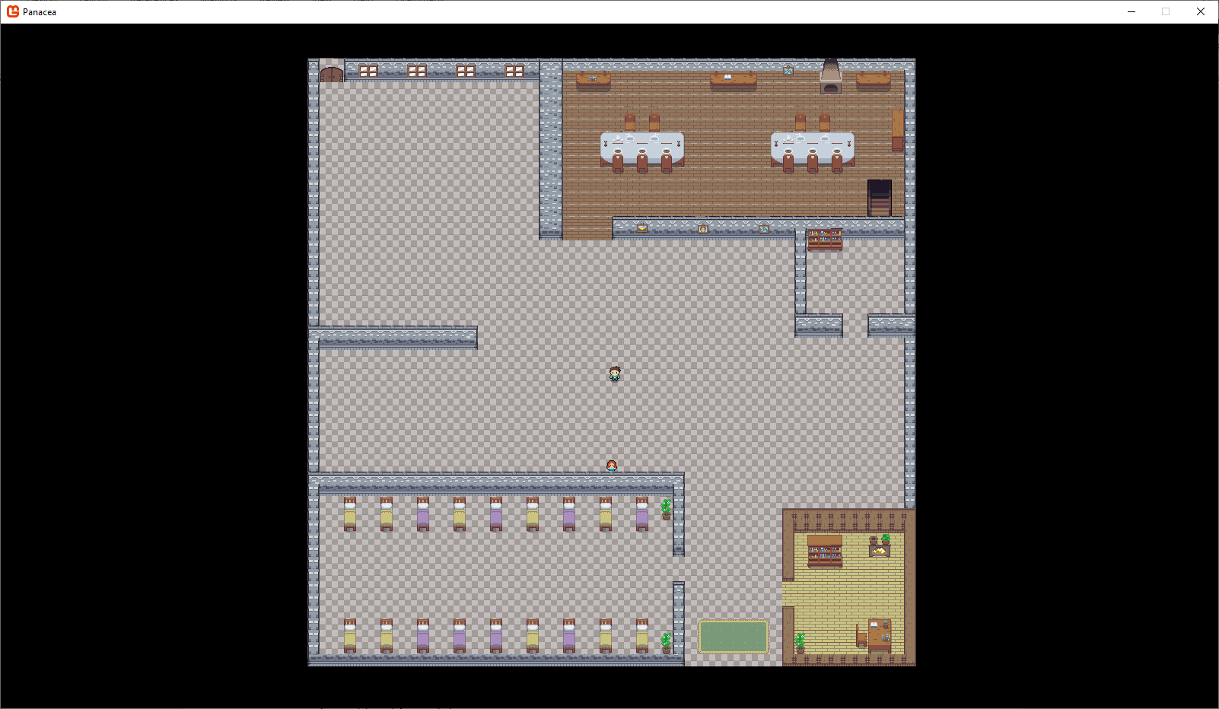

Figure 6: A Zoomed-out view of the game.

additionally, this camera system is beneficial as it also allows the player to enjoy a high-resolution view of the game by zooming in, something that normally would not be attainable with such small pixel art asset images. See below:

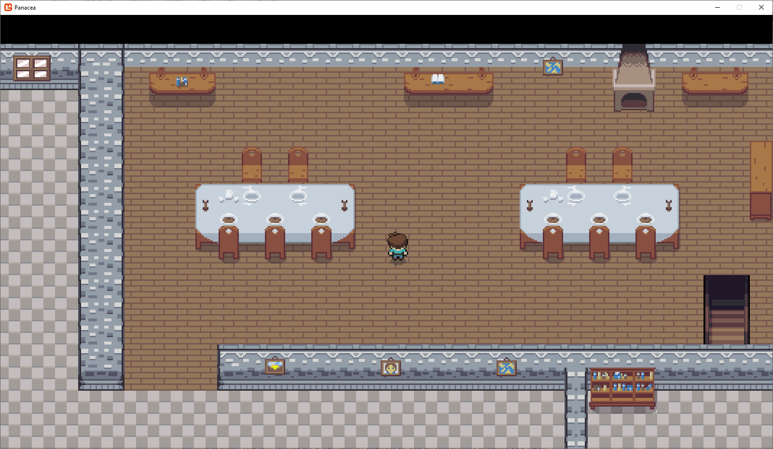

Figure 7: A zoomed-in view of the game, showing off the finer image detail.

Mechanic / Feature 6:*Sprint Mechanic (With a changing animation)*

The sprint mechanic was something that was needed from the original game design since it detailed a fast-paced, intensive environment where the player had to rush around treating patients. This mechanic was implemented for this reason.

It was also not very difficult to implement this since the only real change needed was an extra “Key of Interest” specified in the Player.cs class. The left-shift key was assigned to sprint and operates via a toggle system, where the player can toggle sprint on and off. This feature also meshed with ‘Mechanic 2: *Animated Sprite’* to allow the player token to visually signify when sprint mode has been toggled. Screenshot of the player in sprint mode below:

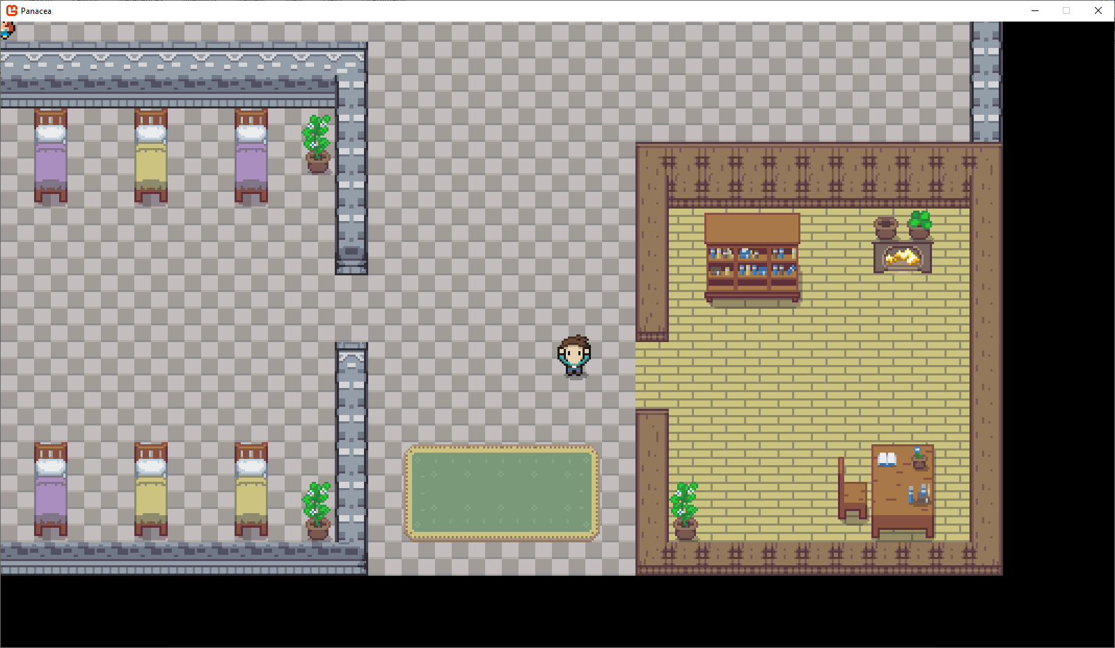

Figure 8: The Player in 'Sprint' mode.

The comical hands-up animation was also chosen to match the theme of the game with its frantic atmosphere and is intended to convey stress in the player’s character (Sam) as he rushes around the hospital wards.

Mechanic / Feature 7:*Roaming NPCs using a Pathfinding algorithm*

The pathfinding in this game project proved to be the most paramount task of all other mechanics. To start with, research was conducted, and the well-documented A-Star algorithm was decided upon for the Artificial Intelligence in the NPCs, an extension of Dijkstra’s algorithm. The original algorithm was written by Hart, Nilsson, and Raphael (1968). As documented by Patel, A. (2020), the A-Star algorithm is superior to Dijkstra’s algorithm as it implements a heuristic to determine the best cost route to the target node from the current tile’s adjacent nodes. Dijkstra simply attempts to brute force it's way to the target node by ballooning outwards and searching all nodes before moving onto the next. This means Dijkstra’s will also search nodes that are in completely the wrong direction to the destination node. A-Star attempts to remedy this inefficiency by using the heuristic value, which gives the algorithm a hint on when it is getting closer to the destination node, allowing it to make an educated guess on which way to search for the node path. The nice thing about the two algorithms is they always guarantee the shortest path to the destination. The image below demonstrates how the algorithm performs its pathfinding search:



Figure 9: GIF depicting A-Star Pathfinding, from: https://upload.wikimedia.org/wikipedia/commons/c/c2/Astarpathfinding.gif

To implement the algorithm into the current game engine, The Navigation Manager discussed in section 2 of this report was implemented.

The end result means that the game features an NPC wanders around the hospital ward, designed to represent Mary Herbert from the original design document. This will lead nicely into future mechanics where the user will be able to talk to Mary as she roams around to gain insight into the lore of the game as well as providing helpful tips. Interacting with Mary was also one of the main ways in which the game will present a learning opportunity for the player. Mary will wait for 5 seconds once she has reached her destination tile before moving along. As stated by Jones, V. (n.d., pg. 29), Mary Herbert was actually a real-life historical character, who was the Matron at the Royal Worcester Infirmary in the late 1800s.

Below is an image representing what the Pathfinders ‘see’ when they navigate around to world. Green tiles are walkable and they can select any of those tiles to path to. Red ones are not selectable and can not be pathed to.

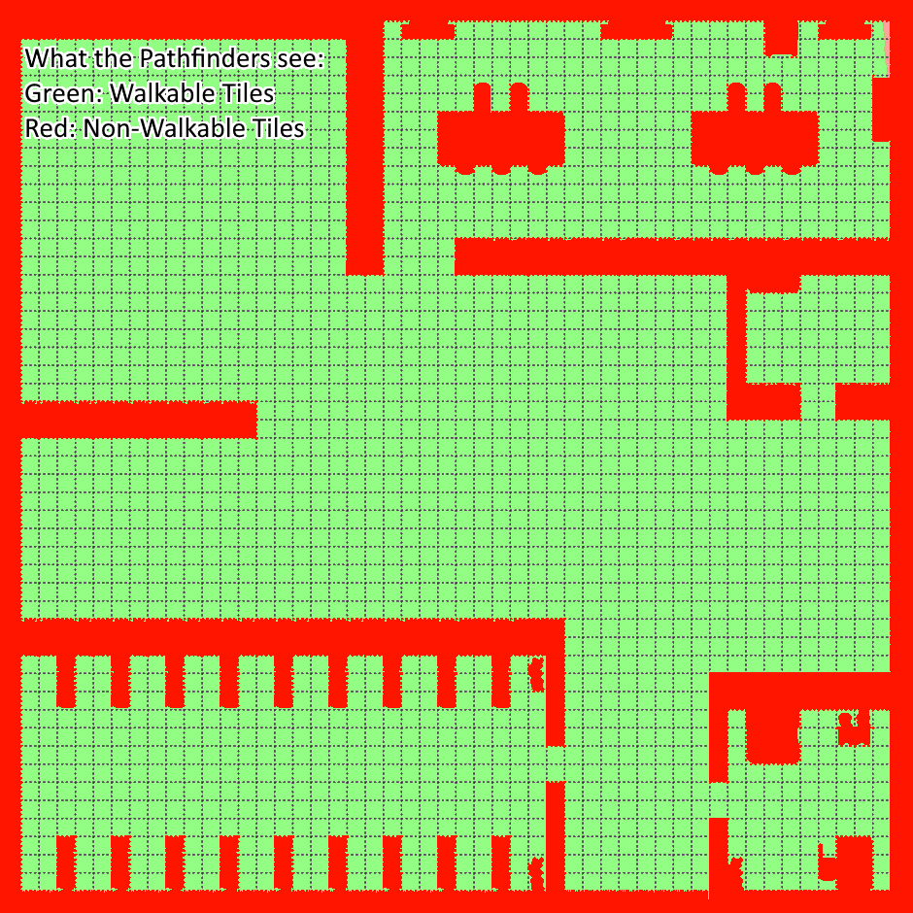

Figure 10: A representation of what Pathfinders see when navigating.

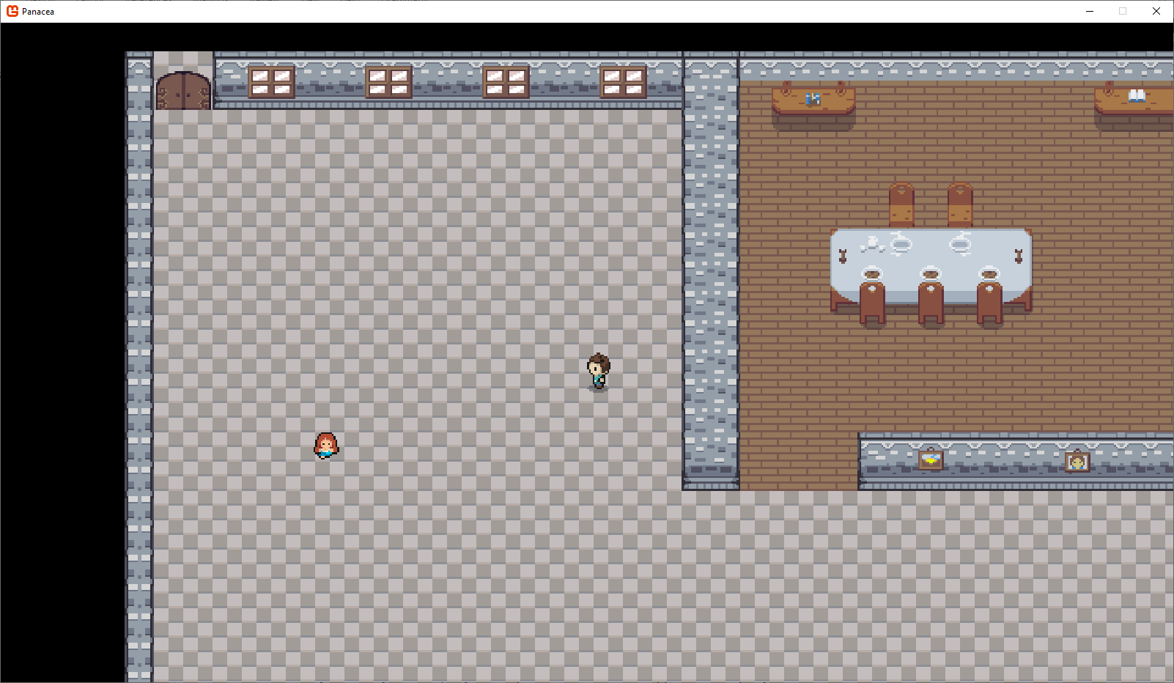

Figure 11: Mary wandering around the hospital wards, utilizing the A* Pathfinding Algorithm.

# Reflection on the game development project

## What went well

There are a few parts of this project that went well. Firstly, the Splitting classes as much as possible to avoid creating a god class, and to make the program more readable, maintainable, and easy to understand (I.E splitting all game assets from Kernel into a GameContent class).

I’m very proud of the way sprite sheets were used to isolate specific images, rather than using 100’s of separate images. This meant the Content manager did not have to load hundreds of images, but only a couple. The specific textures were extracted using a mathematical formula and ‘spacers’ which could be used to draw source rectangles. The GameContent.LoadAnimation method took a lot of planning to interpret a sprite sheet and represent each image mathematically, but the result is a method that can load any animation from any sprite sheet. This makes adding other sprite sheets or swapping out sprite sheets really easy.

Furthermore, the code was generalized so that it could be re-used. For instance, the draw method in kernel can draw all sprites through their abstract class “GameEntity”. The managers were also completely generic from Pong, meaning nothing had to be changed in the actual managers to make the game work, bar a few optimisations and additions.

Additionally, user input was handled well. Mouse input was added as well as a keyboard which was all handled through delegates/events.

To make object referencing easier, a dictionary was implemented, and objects could be referenced through the use of an Enum. This slightly more advanced method of accessing stored elements completely removed the use of FOR loops and index numbers when accessing animations, and meant that specific assets could be easily identified, located, and retrieved.

Also, the TileMap system worked out well since it re-uses already programmed code from the engine to draw itself with minimal effort in an efficient way. The user does not have to do much to generate the map, and the map itself makes use of a .csv and FileParser to easily create the map in a specific layout.

Finally, Implementing A-Star pathfinding in the NavigationManager was something I never thought attainable, or even planned fully to include in this version of the project. This is the aspect that outshines the others in this project.

## What could have gone better

*<Reflect on an aspect of the project you struggled with or felt could have gone better>*

There are also a few aspects of this project that could have gone better.

Firstly, more thorough planning before jumping into development would have been beneficial, so the structure of the program could be more refined and well thought out. This could have also helped to make the program more loosely coupled and more cohesive. Producing a few UML diagrams could have been really helpful.

Furthermore, not spending too long going down a ‘rabbit hole’ fixing tiny, nuanced issues that do not really matter, such as minor aesthetics.

Finally, Interfaces should have been written slightly better to include properties, this would have stopped the need for constant casting in Kernel.

## Project management

*<Reflect on your project management. In this context this is a reflection on how well your work aligned with the milestone deadlines, and if you feel any improvements might have made life easier.>*

Since this project was splitting into 4 milestones over the course of the year, GitHub was used to implement appropriate version control. This allowed each version of the software to be backed up and tracked as the development progressed and allowed for overall organisation of the project. This was also useful when implementing individual features, as each mechanic could be created on a separate branch and merged to master once it was completed. This helped with keeping track of deadlines and ensuring features were completed by a schedule/deadline.

The project was managed well since production of the game began as soon as the assignment was received. This meant each aspect could be worked on incrementally and fine-tuned without the stress of an approaching deadline. GitHub was used to ensure that versions were backed up properly and kept track of this was crucial when making tweaks to the previous versions of the engine whilst adding additional game functionality.

Furthermore, as changes were made to the software they were documented immediately. This was to make the documentation process easier with brief notes that could be elaborated on later.

## Milestones

The staggered approach also helped when visualizing concepts of game design and allowed each individual step to be focussed on before moving to the next. This meant things such as game research and context were thoroughly addressed before any development on the engine or game began, which ultimately proved very useful with managing this task when it came to practical implementations.

Changes and new requirements did arise at each milestone, which highlights the iterative nature of game development and provided new challenges with previously were unknown. For instance, the collision management system developed for the engine worked fine with the previous Pong game used to demonstrate it. However, in this stage of the project where the game development began, it proved that it was not a scalable solution and optimization adjustments were needed. This was a healthy part of the process which shows the staggered approach is effective, because if the prototype stopped at a Pong demonstration, then the collision manager issue would have never been detected and addressed.

Overall, the structure of this game development project proved beneficial in abetting learning. Planning the software at each stage allowed the program to be structured and executed in a logical way, such as Loading Content before spawning entities, but just after initialising managers.

# References

Hart, P., Nilsson, N. and Raphael, B. (1968)‘A Formal Basis for the Heuristic Determination of Minimum Cost Paths.’ *IEEE Transactions on Systems Science and Cybernetics*, 4(2), pp.100-107. doi: 10.1109/tssc.1968.300136

Jones, V (n.d.) *Timeline of Worcester Royal Infirmary* Available at: https://worcesterbb.blackboard.com/webapps/blackboard/execute/content/file?cmd=view&content_id=_1552001_1&course_id=_40932_1 (Accessed: 25 November 2020)

Lindeijer, T (2021) *Tiled.* Available at: https://www.mapeditor.org/ (Accessed: 23 April 2021).

Patel, A (2020) *Introduction to A*.* Available at: http://theory.stanford.edu/~amitp/GameProgramming/AStarComparison.html (Accessed: 23 April 2021).

Wikipedia. (n.d.) *A* search algorithm.* Available at: https://en.wikipedia.org/wiki/A*_search_algorithm (Accessed: 23 April 2021).